**Abstract**

Aneuploidy is the phenomenon in which an organism contains a number of chromosomes that is not a multiple of the haploid state. Some populations show tolerance for aneuploidy, including wild yeast isolates (Strope *et al.* 2015). Recently there has been much debate as to why/how these populations maintain aneuploidy. Some hypothesize that there is an innate mechanism of dosage compensation in yeast (James Hose 2015; Audrey P Gasch 2016). Others rebut this argument, claiming there is no evidence for dosage compensation at the whole-chromosome level in yeast (Eduardo M Torres 2016). An alternative hypothesis is that the tolerance of aneuploidy is a transient adaptive state, as supported by studies of yeast on oxide-rich media and other selective environments (Kaya *et al.* 2015; Wakabayashi *et al.* 2017; Koo *et al.* 2018). In order to determine if there is an intrinsic mechanism of dosage compensation in yeast, we analyzed whole transcriptomes from 46 euploid and aneuploid yeast samples from two mutation accumulation studies with strains of different genetic backgrounds: one highly heterozygous hybrid of two wild strains, and one highly homozygous laboratory strain. We performed differential expression analysis and found that there is no evidence for dosage compensation at the whole-chromosome level, but some individual genes are differentially expressed. The environmental stress response was also initiated in the aneuploid samples. These findings add to our understanding of the evolution of dosage compensation mechanisms, and help support the hypothesis that aneuploidy tolerance is likely a transient adaptive mechanism, not because of an innate dosage compensation response.

**Introduction**

Aneuploidy is the phenomenon in which an organism contains an abnormal chromosome number, i.e. one not a multiple of the haploid state. The most commonly referred to aneuploidies are those causing human diseases (trisomies 18, 21, and some X chromosome aneuploidies being viable; others stillborn) (Hassold and Hunt 2001). There is some debate as to why aneuploidy is often maintained (or tolerated) in populations, such as in some wild yeast isolates (Strope *et al.* 2015). Some hypothesize there is an intrinsic mechanism of dosage compensation to buffer the deleterious effects of imbalanced gene dosage (James Hose 2015; Audrey P Gasch 2016), similar to the mechanism of dosage compensation observed in sex chromosomes (Marin *et al.* 2000) or autosomal compensation in *Drosophila* and other species (Birchler *et al.* 1990; Matos *et al.* 2015). Others contest this argument, claiming there is no evidence for dosage compensation at the whole-chromosome level in *S. cerevisiae* (Eduardo M Torres 2016). An alternate hypothesis to a mechanism of whole-chromosome modulation of imbalanced gene expression is that the accumulation or loss of chromosomes is an adaptive advantage to stressful environments, such as the case with yeast in an oxide-rich media that accumulate an extra copy of chromosome XI to tolerate oxygen stress (Kaya *et al.* 2015), and other studies which imply an adaptive advantage to aneuploidy (Wakabayashi *et al.* 2017; Koo *et al.* 2018). Others provide the explanation that the yeast seen in the wild actually attenuate protein levels by increasing protease activity or upregulating genes that are part of multiprotein complexes so that the dosages are even (Chen *et al.* 2003; Veitia *et al.* 2008).

Sex chromosomes evolved from autosomes (Charlesworth 1991). It is known that there is a variety of ways that sex chromosomes employ dosage compensation to make up for differences in gene expression between the sexes (Chandler 2017). Dosage compensation has also been observed in some autosomes, such as in *Drosophila* (Devlin *et al.* 1982; Birchler *et al.* 1990; McAnally and Yampolsky 2009; Chen and Oliver 2015; Hangnoh Lee 2016). However, it is unknown whether there is an intrinsic dosage compensation mechanism in yeast to overcome the stressful effects of aneuploidy. Yeast are often found to be aneuploid in natural isolates (Strope *et al.* 2015). There are multiple hypotheses as to why this may be the case: they could be growing in an environment that is stressful and selection favors aneuploidy to increase or decrease the expression of certain genes (Kaya *et al.* 2015; Linder *et al.* 2017) yeast may be naturally robust to aneuploidy, or they may contain a natural mechanism for attenuating or compensating for differences in gene expression.

Previous studies have observed the effects of aneuploidy in wild yeast populations, which may be heterogenous (CITE) or have undergone selection for aneuploidy in a stressful environment (Linder *et al.* 2017), and chemically- or mitotically-induced aneuploids (Campbell *et al.* 1981; Anders *et al.* 2009; Mulla *et al.* 2014). Here, we investigate the rate, types, and effects of aneuploidy in spontaneously aneuploid yeast that have been put through a 2000-generation mutation accumulation experiment with a single-cell bottleneck every 20 generations (Zhu *et al.* 2014). Our study looks at the effects of aneuploidy in samples that have spontaneously gained or lost chromosome(s) in the absence of selection, enabling us to disentangle the costs and benefits of aneuploidies from the base phenomenon itself. The absence of selection allows us to analyze the transcriptome without bias from environmental factors, enabling us to determine the effects of aneuploidy on the genome in a stable condition and without selecting for any particular aneuploidies or mutations. Only the most detrimental mutations will be purged from the populations, which also allows us to determine what aneuploidies are the least and most tolerated.

This study aims to determine if there is a common mechanism of dosage compensation in *Saccharomyces cerevisiae* by analyzing RNAseq data from 46 euploid and aneuploid samples from two mutation accumulation experiments with strains of different genetic backgrounds. Average gene expression across each entire chromosome was determined, and statistical analyses were used to determine if it was as expected with and without dosage compensation. We found no evidence for whole-chromosome dosage compensation in aneuploid yeast. Next, we observed whether or not there was statistically significant dosage compensation in individual genes (partial, full, anti-, or over-compensation), and found that the majority of genes on aneuploid chromosomes are not compensated, and those that show some form of compensation are at most partially compensated. No statistically-significant fully-dosage-compensated genes were found in any of our samples. We also found gene expression levels for environmental stress response genes, aneuploid stress response genes, and dosage-sensitive genes found in previous studies (Torres *et al.* 2007; Torres *et al.* 2010; Makanae *et al.* 2013; Bonney *et al.* 2015). We conclude that there is no dosage compensation mechanism in lab and hybrid strains of *S. cerevisiae*, and that mutation accumulation and aneuploidy both incite an environmental stress response in yeast.

Notes:

Further studies will be needed to:

Look at protein levels – maybe some genes that are not compensated at the RNA level are instead degraded at the protein level

Can look at budding in aneuploids: is it different than euploids (similar to how budding is different between haploids and diploids): inefficiency of segregation? Cell cycle inhibitors?

How often do aneuploidies arise in the absence of selection?

and what are they, what are their fitness effects?

-Get aneuploids in the wild, but that could be from selection in a potentially stressful environment (ie oxidative stress)

Looking at spontaneous aneuploidies in the absence of selection allows us to get a baseline for how often these spontaneously arise

Looking for if there is a common mechanism of DC in autosomes. Sex chromosomes evolved from autosomes, so they may have brought with them some inherent way of compensating for multiple gene copies.

**Methods**

*Strains, RNA extraction, and sequencing*

The strains used were obtained from previous mutation accumulation experiments, one from a hybrid of NCYC 3631, a Mat alpha derivative of YPS 606 (oak strain, PA, USA), and NCYC 3596, a Mat a derivative of DBPVG1106 (lici fruit, Indonesia, wine clade) (unpublished data). This hybrid strain was highly heterozygous, with a heterozygous site every ~250 bp (unpublished data). The other strain used was a lab strain from a different mutation accumulation experiment and had the genotype *ade2, lys2-801, his3-∆D200, leu2-3.112, ura 3-52,* and was homozygous at all loci except the mating type locus (Zhu *et al.* 2014). Both strains from the separate mutation accumulation experiments were diploid and put through a bottleneck every ~20 generations for ~2000 generations.

30 lines from both experiments (12 aneuploid hybrid ancestor, 8 euploid hybrid ancestor, 6 aneuploid lab strain, 2 euploid lab strain), 3 replicates of each, were inoculated in 3ml liquid YPD (yeast extract 2%, peptone 2%, glucose 2%), and incubated on a rotator at 30° C for 24 hours. RNA was extracted using the MasterPure Yeast RNA Purification Kit (Epicentre). Integrity, concentration, and quality of RNA samples were assessed using the Qubit. Libraries were prepared using the Illumina Stranded RNAseq Kit. They were sequenced at the Georgia Genomics Facility on the Illumina NextSeq (75 cycles) SE75 High Output flow cell. Samples were multiplexed and split across two runs.

For the previously sequenced RNA, we selected 45 colonies (3 replicates each of 15 lines), inoculated each into 3 ml liquid YPD medium, and incubated on a rotator at 30 for 24 hours. After 24 hours, mRNA was extracted using the MasterPure Yeast RNA Purification kit (Epicentre). RNA libraries were constructed using the Illumina Tru-seq mRNA Stranded Kit, amplified using 13 cycles of PCR and sequenced on an Illumina HiSeq 2500.

Because these datasets were extracted by different individuals, libraries were made with different kits, and the samples were run on different sequencing machines, analyses were carried out separately, although identically.

*RNAseq data analysis*

Raw data was obtained from the Georgia Genomics Facility, with adapters removed. Quality control was done using FastQC version 1.8.0_20 using default parameters (available at <https://www.bioinformatics.babraham.ac.uk/projects/fastqc/>). Low-quality bases were trimmed using Trimgalore v. 0.4.4 using -phred 33, -q 20 (available at https://www.bioinformatics.babraham.ac.uk/projects/trim_galore/). RNA samples were aligned to the reference genome and annotated transcripts (obtained from <https://support.illumina.com/sequencing/sequencing_software/igenome.html>) using Tophat v. 2.1.1 with -i 10 -I 10000 (Trapnell *et al.* 2012). Cufflinks v. 2.2.1 was used to assemble the transcriptomes using default parameters (Trapnell *et al.* 2012). Normalization was done using Cuffnorm v. 2.2.1 with default parameters, differential expression was found using Cuffdiff v. 2.2.1 with default parameters, and read counts were found using HTseq v. 0.6.1pl (Python v. 2.7.8) (Anders *et al.* 2015). Samtools (version 1.3.1) was used to convert .sam files into .bam files and sort the resulting .bam files (Li *et al.* 2009). Scripts can be found at <https://github.com/hollygene/Dosage_Compensation/blob/master/assembly_script.sh>.

Genes were filtered to eliminate those genes with high variance. edgeR (Robinson *et al.* 2010) was used to calculate counts per million, then filtered based on high variance. The ancestral replicates were used to find the highly variable genes. It was found that the majority of the genes with high variance also had a cpm < 1, so those genes were removed from the following analyses. The resulting list of genes were used in all subsequent analyses. Approximately 1300 (~1.8%) genes were removed from the analysis.

Cuffnorm (Trapnell *et al.* 2012) was used to find FPKM (fragments per kilobase per million reads). A homebrew bash script was used to join the FPKM values for each line with the gene attributes file, turn the file into a .csv, remove mitochondrial sequences, and change the chromosome names from Roman numerals to numbers (script can be found at <https://github.com/hollygene/Dosage_Compensation/blob/master/DC_workflow_April2017.sh>). This data file was then read into the R statistical software (Team 2013). Average FPKM between the replicates for each line at each chromosome was found, followed by the average FPKM ratio (average FPKM of descendent line/average FPKM of ancestral line). A total of 6181 genes were analyzed, after filtering out reads with an average across samples of 5 or less. Boxplots and ANOVAs were done in R. Comparisons made between aneuploid lines and the expected log2 ratio of the gene expression of trisomic, monosomic, or tetrasomic chromosomes were made using a one-sample t-test with mu = log2(1.5) for trisomic, mu = log2(0.5) for monosomic, and mu = log2(2) for tetrasomic. Two separate, but identical, analyses were done for each of the datasets. R scripts are located at <https://github.com/hollygene/Dosage_Compensation/blob/master/DC_workflow_old_MA.Rmd> and <https://github.com/hollygene/Dosage_Compensation/blob/master/DC_workflow.Rmd>.

Individual gene analysis was performed using raw count data obtained from HTseq and DESeq2 (Anders *et al.* 2015). Raw read counts obtained from htseq-count were used as input. Individual DESeqDataSets were produced for each sample, due to the high amount of variation found between replicates (PCA), as suggested by DESeq2 (CITE). Each sample was paired with the corresponding ancestral replicates in a dataset. Sequencing run and sample group were used as variables. Reads were filtered by only keeping those genes in the ancestor with read counts greater than 10. A total of 5532 genes were analyzed. The DESeq function was ran on all datasets with default parameters. Annotations were added using the TxDb *S cerevisiae* database (Carlson M 2015). The results() function in DESeq2 was ran with default parameters, using a FDR of 0.1. Previous studies have used almost exclusively FPKMs as gene expression units. Newer research has found that this is not the best method (CITE). Instead, raw reads are put into a pipeline that does internal normalization across samples. For my experiment, I normalized each sample to the ancestor individually, since I have so many aneuploid samples that could skew the normalization. Genes were filtered based on whether or not there were 10 or greater counts in all 3 ancestor replicates (i.e. genes with fewer than 10 counts in all 3 ancestor replicates were discarded). Because of high variance between two of the replicates, only 2 ancestor replicates from the “newer” lab strain samples were used.

Ratio distributions were produced using the normalized counts obtained from DESeq2 to find the ratio of the sample mean divided by the ancestral mean. Histograms were generated using ggplot2 in the R package (Wickham 2016). Genes with ratios >6 were pooled in one column.

We found what genes are commonly found to be DE in the euploids and extracted those from the aneuploid datasets. This ensures that we distinguish between a general expression response to MA from the effects of aneuploidy. To find commonly DE genes in aneuploid samples, we then combined aneuploid datasets to find genes that are DE 2 or more aneuploid samples. This gave us an idea of a general “aneuploid stress response” as seen in previous studies (Torres *et al.* 2007).

To determine if different samples react to the same aneuploidy in the same manner, samples with the same aneuploidy(ies) were compared to one another to determine the number of commonly DE and non-DE genes (FIGURE?). To find if there is any significance in the types of genes that are commonly DE/not DE in aneuploid and euploid samples, gene ontology analysis was performed on datasets of common DE/non-DE genes in aneuploids and euploids using the PANTHER GO system (Thomas *et al.* 2003).

We analyzed genes in the environmental stress response (ESR) and dosage sensitive genes (DS) (Gasch *et al.* 2000; Makanae *et al.* 2013). We also analyzed aneuploid stress response genes from Torres et al 2007. These were genes that were significantly differentially expressed (DE) in the aneuploid lines but not sig differentially expressed in euploids (Torres *et al.* 2007). To identify significantly differentially expressed genes from these categories, we tested each gene’s expression against the expected expression for a disomic gene (lfc=0), then determined which genes are significantly different, then parsed those genes into what matches the ESR/DS/ASR genes. We then combined those genes from each sample into one file and counted how many times each gene appeared (i.e. how many samples is it DE in). We also summarized the ESR/DS/ASR DE gene percentages from each aneuploid line and each chromosome that line was aneuploid for.

**Results**

*Rate of spontaneous aneuploidy is nearly twice as high in hybrid strain than lab strain*

The rate of spontaneous aneuploidy in the heterozygous hybrid strain was 1.82 x 10-04 events per genome per generation. The homozygous lab strain had a significantly lower rate of 1.04 x 10-04 events per genome per generation, about half that of the heterozygous lab strain (*p*=0.0106, Fisher’s exact test, figure 1, table #). Previous studies have found that chromosome V is lost spontaneously in *S. cerevisiae* at a rate of 2-8 x 10-6 cell generations (Mulla *et al.* 2014).

For the lab strain, 31 out of 145 sequenced samples were found to be aneuploid (Zhu *et al.* 2014). Of these, 29 had whole-chromosomal duplications, and 2 had whole-chromosomal deletions (Zhu *et al.* 2014). No segmental duplications were found in the lab strain samples. 4 samples contained multiple aneuploidies (i.e. two separate chromosomes had become aneuploid). Half of the chromosomes (8 total) were found to be aneuploid in multiple individual samples. In total, there were 29 trisomy events.

In the hybrid strain, 29 out of 76 sequenced samples were found to be aneuploid. Of these, 27 were trisomic, 1 was monosomic, and 1 was tetrasomic. One sample had a partial duplication of chromosome X. Eight of the hybrid strain samples contained multiple aneuploidies. In total, there were 38 trisomy events in the hybrid strain samples.

Across the two experiments (29+27 = 56 trisomies), expect this distribution of chromosomes that are trisomic. Note that only 2 chromosomes are expected to have zero trisomies and none are expected to have more than 9.



Across both experiments, this is the actual distribution of trisomies. 10 chromosomes have zero trisomies, which indicates that aneuploidy is not random and is selected against in certain chromosomes.

Hybrids of two yeast species have been shown to systematically lose all or part of one parent’s genome (Marinoni *et al.* 1999). It is possible that our hybrid of distantly related *S. cerevisiae* strains may show a milder version of genome incompatibility as exemplified by the higher rate of aneuploidy compared to the homozygous lab strain.

Chromosome IX was aneuploid most often in the homozygous lab strain (5 independent aneuploidy events – 2 monosomies and 3 trisomies). A previous study found that chromosome IX was highly unstable in terms of chromosome loss in both diploid *S. cerevisiae* and diploid hybrid *S. cerevisiae-S. bayanus* strains (Kumaran *et al.* 2013). In the hybrid strain, chromosome XVI was aneuploid most often – with 9 trisomies and 1 tetrasomy.

Certain chromosomes are detected at higher frequencies (Chrs V,VII,IX,XII, and XVI), suggesting that duplication (and deletion, in the case of chromosome IX) of genes on these chromosomes is better tolerated than on other chromosomes (i.e. chrs VI and XIII, which were not found to be aneuploid in either experiment). Only two chromosomes were found to be monosomic – chromosome I and IX, which are both relatively small chromosomes (I is the smallest with 230218 bp, while IX is the 4th smallest with 439888 bp). This suggests that while there is no noticeable effect of chromosome length on aneuploidy occurrence (FIGURE?), monosomy may be tolerated in smaller chromosomes better than larger chromosomes.

*Segmental Duplications*

Hybrid sample 76 had a partial duplication of chromosome X. It appears that a segment of chromosome X was duplicated and then attached to another chromosome; it is not a structural duplicate of the chromosome arm, as the segment does not include the centromere. It appears that the initial breakpoint is around 24,400, and the ending breakpoint is located at 378,020 (figures 2 and 3). The ending breakpoint is in close proximity to a known transposable element (within 200 bp of the YJLCdelta7 Ty1 LTR), which makes locating this mutation difficult. Chromosome X in yeast has a centromere that begins at 436,307; the duplication of the left arm does not include the centromere. The initial and final breakpoints are both located in intergenic sequences, so likely do not have a phenotypic effect aside from that of the duplicated genes. Visual analysis of the genome identified two candidate chromosomes for part of chromosome X to be attached to: chromosome VI and chromosome XI. These chromosomes showed significant reductions in read count near the end of one of their chromosome arms.

This sample is also trisomic for chromosome IX and chromosome XIV. It is possible that the duplication of half of chromosome X aids in the dual aneuploidy, by balancing protein stoichiometries for example. In order to investigate this, we looked at the individual gene expression profile of sample 76 to determine if there were any correlations between genes on these three chromosomes.

*No evidence for whole-chromosome dosage compensation in either lab or hybrid strains*

Whole-chromosome gene expression was analyzed by calculating the average and 95% confidence interval of gene expression for each chromosome (boxplots in figure 7). ANOVAs were also run on each aneuploid sample, comparing the average ~~its~~ gene expression from each chromosome to that of the other samples. If there is compensation occurring on the whole-chromosome level, we would expect statistically insignificant p-values from ANOVAs of aneuploid chromosomes compared to the ancestral chromosome state. There is no evidence of whole-chromosome dosage compensation, as every sample that was aneuploid showed a significant p-value ( < 0.01) in the ANOVA. However, further analysis is needed, as some euploid lines also showed significant ANOVA p-values, indicating that a simple ANOVA is not sufficient to determine the level of gene expression differences between samples.

Most, but not all, aneuploid samples had nonsignificant p-values when comparing the gene expression on the aneuploid chromosome to the expected value of gene expression of a monosomic/trisomic/tetrasomic (expected average log2 fold changes of -1, 0.585, and 1, respectively) chromosome assuming no dosage compensation. (Sample 18, chromosome I, p <0.05; sample 49, chromosome V, p<0.05;sample 59, chromosome VII, p<0.05;sample 61, chromosome VII, p<0.05) Together, these observations support the conclusion that there is no whole-chromosome dosage compensation occurring in either the hybrid or lab strains. The RNA levels of aneuploid chromosomes in samples with known aneuploidies are not statistically significantly different than expected given the DNA ratio. These findings are supported by previous work showing no dosage compensation in aneuploid yeast (Torres *et al.* 2010).

|  |  |  |  |  |  |  |
| --- | --- | --- | --- | --- | --- | --- |
| Chromosome | Sig (p < 0.01) MA Lines | Aneuploid? | Significant (p < 0.01) GC Lines | Aneuploid? |  |  |
| I | 152 | Y | 7, 11, 18 | Y,Y,Y | all aneuploid for chromosome I | |
| II | - | - | - | - |  |  |
| III | - | - | 11,18,76 | Y,Y,Y | but aneuploid for diff chromosomes than III | |
| IV | 9, 108 | Y, Y but not for IV | 2,3,5,7,18,59,61 | N,N,N,Y,Y,Y,Y,Y | aneuploid samples not aneuploid for IV | |
| V | 5, 112, 117, 123 | N, Y, Y, Y for V | 4, 49, 61, 76 | Y, Y, Y, Y | 4 and 49 actually aneuploid for chromosome V | |
| VI | - | - | - | - |  |  |
| VII | - | - | 2,3,5,7,18,49,59,61,76 | N,N,N,Y,Y,Y,Y,Y | 59 and 61 actually aneuploid for chromosome VII | |
| VIII | 152 | Y not for VIII | 18, 49, 76 | Y,Y,Y | 18 and 152 both aneuploid for chrom I | |
| IX | 3,15,29,50,88,108,119,152 | N,Y,Y,Y,N,Y,Y,Y,Y 15, 88, 108, 119 actually aneuploid for chr IX | 2,3,18,61,76 | N,N,Y,Y,Y | 76 actually aneuploid for IX | |
| X | - | - | 3,18,76 | N, Y, Y | 76 actually aneuploid for X | |
| XI | 108 | Y | 2,3,18 | N,N,Y |  |  |
| XII | - | - | 3,4,7,8,11,18,49,59,61,76,77 | N,Y,Y,Y,Y,Y,Y,Y,Y,Y,Y,Y | |  |
| XIII | 112 | Y | 2,3,5,7,18,49,61,76 | N,N,N,Y,Y,Y,Y,Y | |  |
| XIV | 9 | Y | 11,18,61,76 | Y,Y,Y,Y | 76 actually aneuploid for chromosome XIV | |
| XV | - | - | 2,3,11,18,49,59,61 | N,N,Y,Y,Y,Y,Y,Y | 11 actually aneuploid for chromosome XV | |
| XVI | 9,29,112,115 | Y,Y,Y,Y | 2,3,5,8,18,49,61,76,77 | N,N,N,Y,Y,Y,Y,Y | 8 actually aneuploid for chromosome XVI | |

Ratios of gene expression levels from each sample to the ancestor were calculated and plotted for all genes in the euploid samples (figure 13), for genes on the aneuploid chromosome(s) in aneuploid samples (cis genes), and for genes not located on the aneuploid chromosome(s) in aneuploid samples (trans genes) (figure 8). Some samples were highly variable in their expression levels; however, the average ratio across each aneuploid chromosome in question was as expected: centered around 1.5 for trisomic samples, 0.5 for monosoic samples, and 2 for tetrasomic samples (figure 8). The cis genes were clustered around the expected ratios (dependent on the type of aneuploidy: for monosomic chromosomes, expected ratio is 0.5, for trisomic chromosomes, the expected ratio is 1.5, and for tetrasomic chromosomes the expected ratio is 2). The trans genes also showed the expected trend: if you have a duplication of a chromosome, then the amount of DNA that is sequenced from this chromosome is higher than the amount of DNA sequenced from each of the other 15 chromosomes (e.g. chromosome II has less DNA reads than chromosome I). The DNA content of the euploid chromosomes (trans genes) in the aneuploid progenitor is less than the DNA content of the euploid chromosomes (trans genes) in the euploid ancestor, so the ratio you get when you compare these is less than 1. The amount of decrease or increase depends on the size of the chromosome and the type of aneuploidy (i.e. for monosomies, the trans gene ratio will increase (>1)). When the chromosome is duplicated, it increases the amount of DNA that the particular chromosome gets for sequencing and reduces the number of reads given to genes on the other chromosomes. The expected ratio of trans genes in a sample trisomic for chromosome I is 0.98130081. The average ratio observed on chromosome I is __. The ratio shown here does not demonstrate an expression effect from the aneuploid chromosome per say, but an artifact from sequencing. Previous studies have proposed that there is an effect of aneuploidy on the remainder of the genome, by looking at the peaks of the distributions and claiming that the apparent skew to the left of 1.00 indicated that the aneuploid chromosome was causing other expression effects in the genome (CITE HOU et al paper).

**Individual Genes**

*Individual Dosage-Compensated Genes*

We defined five groups of gene expression: no dosage compensation, partial dosage compensation, full dosage compensation, anti-dosage compensation, and over-dosage compensation. Most aneuploid samples had predominantly anti-compensated genes. The average percent of genes with anti-compensation on the aneuploid chromosome was 2.7% across all aneuploid chromosomes tested. The average percent of genes with over-compensation was 0.2% and there were no genes on any aneuploid chromosome that showed statistically significant partial or full dosage compensation.

To determine if there were any statistically significant dosage-compensated genes, we performed a test to parse out the specific types of gene expression we were looking for, using the same metrics as Malone et al 2012 (Malone *et al.* 2012). In the first test, we tested the hypothesis that the expression of the gene was equal to the expected dose for the DNA copy number of that gene. For example, 1x genes would have an expected expression level of -1 log2fold change when compared to the ancestor. 2x genes would have log2fold change equal to 0, 3x genes would have log2fold change equal to 0.585, and 4x genes would have log2fold change equal to 1 when compared to the ancestral gene expression level. If the gene was found to be statistically insignificant (FDR p-value > 0.1), then there was no dosage compensation detected for this gene. If, however, the gene was found to be statistically significantly different than the expected dose (FDR p-value<0.1), further tests were needed.

In the second test, we determined if the expression of the gene was equal to the expected dose of disomic (euploid) genes, a log2fold change of 0. If the gene was found to be statistically significantly different than the expected dose (FDR p-value <0.1), it was considered partially, over-, or anti-compensated, and further investigation was required. If the gene was found to be statistically insignificant (FDR p-value > 0.1), the gene was considered to be fully dosage compensated.

To further break down the type of compensation, a gene was considered to be partially dosage compensated if the test against expected gene expression came back significant, but test against expected dose of disomic genes also came back significant. A gene was considered over-compensated if the test against expected gene expression came back significant, but test against expected dose of disomic genes came back significant AND the gene expression was less than (or greater than for monosomic genes) expected for disomic genes. If the test against expected gene expression came back significant, but test against expected dose of disomic genes came back significant AND the gene expression was skewed in the opposite direction of dose expected of disomic genes, the gene was classified as anti-compensated.

*Samples with the Same Aneuploidy Have Similar Gene Expression Patterns*

Samples with different aneuploid chromosomes shared differentially expressed trans (located on a chromosome other than the aneuploid chromosome) genes (figure 9). Further, euploid samples had a set of commonly differentially expressed genes, and these were indicated to be involved in mitochondrial processes, according to gene ontology analysis (figure 10). This result suggests an effect of mutation accumulation on gene expression.

Hybrid sample 11 is monosomic for chromosome I and is the only sample that had any over-compensated genes. However, we cannot compare this sample to the other 3 samples that have an aneuploid chromosome 1 since they are trisomic. None of the trisomics had any partially, full, anti-, or over-compensated genes.

Only hybrid sample 4 and lab sample 123 (both trisomic for chromosome V) had any partially DC genes, and they only shared one. Interestingly, this gene was overcompensated in line 4 and anti-compensated in line 123, suggesting different effects depending on genotype.

Hybrid samples 59 and 61 are both trisomic for chromosome VII and share 12 potentially compensated genes. 2 of these genes are over-compensated, while the remaining 10 are anti-compensated. Sample 59 had two genes that were potentially DC that were not shared with sample 61, and sample 61 similarly had 8 genes not shared, suggesting that the individual sample had an impact on what genes received compensation.

Lab samples 152 and 108 share a trisomy for chromosome 8. They only share one potentially compensated gene, and it is anti-compensated in both samples. Each sample had several other potentially compensated genes, but only one was common between the two which may be due to each line also having another aneuploidy on a different chromosome that could impact the gene expression on this chromosome.

Lab samples 29 and 88 are the only two samples with an aneuploidy on chromosome IX that share any compensated genes. In both samples, the gene is anti-compensated (gene expression is heavily skewed in the direction of the aneuploidy) - sample 88 has a trisomy and sample 29 has a monosomy.

Hybrid sample 76 and lab sample 9 are both trisomic for chromosome XIV. They share one anti-compensated gene, but each have their own set of other anti- and over-compensated genes that are not shared. This further suggests an influence of genetic background on gene expression in aneuploids.

Lab sample 112 and hybrid sample 8 both have aneuploidies for chromosome XVI – sample 112 has a trisomy and sample 8 has a tetrasomy. They do not share any potentially compensated genes, and sample 8 has 67 anti-compensated genes. Sample 112 does not have any anti- or partially-compensated genes.

*Histone Genes*

Histone genes H2A and H2B are known to possess a mechanism of dosage compensation in *S. cerevisiae* (Osley and Hereford 1981; Medici *et al.* 2014). Our analyses did not include samples with aneuploidies on these chromosomes (II and IV), but a couple of samples are aneuploid for a chromosome containing other histone genes (XIV, XV, and XVI; histone 3,4, and linker, respectively). Previous studies have found that these genes do not display dosage compensation, and our results agree (Peter R. Eriksson 2012).

*Environmental Stress Response Genes*

Yeast are known to undergo what is known as the environmental stress response (Gasch *et al.* 2000; Zillikens *et al.* 2017), when conditions are unfavorable due to various factors, including temperature stress, oxidative stress, and nutrient limitation. We analyzed the same genes that Gasch et al found to relate to the environmental stress response and found that our samples did differentially express some of these genes (figure 24). Several sampled that were aneuploid for the same chromosome shared differentially expressed ESR genes (figure 24). It was more common for the samples with the same genetic background to express similar ESR genes than across the two genetic backgrounds, as expected.

It has been found that similarly, aneuploid yeast undergo what is referred to as the “aneuploid stress response,” in which certain genes NOT located on the aneuploid chromosome are differentially expressed (Torres *et al.* 2010). Our samples do have commonly differentially expressed genes that are not located on the aneuploid chromosomes (Figure 9). Most of these genes are also differentially expressed during the environmental stress response. Curious as to if we found the same genes and patterns in our spontaneously aneuploid samples, we investigated the same genes as Torres et al and found in GC lines that 51 genes were significantly differentially expressed in at least one aneuploid line, and that 8 genes were significantly differentially expressed in 8 aneuploid lines. In MA samples, from the first set of RNA data, 86 genes were significantly differentially expressed in at least 1 aneuploid line, 104 were differentially expressed in 2 aneuploid lines, and 30 were differentially expressed in 3 aneuploid lines. In the MA lines from the newer set of RNA data, 62 genes were significantly differentially expressed in at least 1 aneuploid line, 20 were differentially expressed in 2 aneuploid lines, and 3 were differentially expressed in 3 aneuploid lines. The total number of ASR genes analyzed was 201, and all 201 of these genes were found to be differentially expressed in some capacity in Torres et al 2007.

What about the euploids? Was there a common ESR response from them? Maybe from MA?

*Dosage-Sensitive Genes*

Most aneuploid samples had few differentially expressed dosage sensitive genes. These dosage-sensitive genes were found in the study (Makanae *et al.* 2013), which found 115 genes that had copy-number limits of 10 or less. We investigated these same genes to determine if our aneuploid samples were regulating them. Those that are attenuated on aneuploid chromosomes may indicate strong dosage sensitivity, and that the yeast are able to compensate for this sensitivity by increasing or decreasing transcription accordingly.

If there is no dosage compensation happening, regardless of the gene, then all genes would be expressed as much as their aneuploidy would suggest (i.e. for monosomic genes, 0.5x the amount of a disomic gene, for trisomic genes, 1.5x the amount of a disomic gene, and for tetrasomic genes, 2x the amount of a disomic gene). Previous studies have found that certain genes are more dosage-sensitive than others: using the “genetic tug-of-war” method, Makanae et al 2013 found the copy-number limits of overexpression in all 5806 protein-coding genes in *S. cerevisiae*, and found 115 genes whose copy number limits were 10 or less (more than this amount caused cell death). Curious as to whether our samples also showed a pattern of dosage sensitivity with these genes, we investigated the same set of genes that were found to be dosage sensitive in our samples and parsed out those that were significantly differentially expressed (i.e. had a gene expression level significantly different than expected for a disomic gene) and those that were not significantly differentially expressed.

The genes of most interest were those contained on the aneuploid chromosomes, as these genes were found in differing dosage in the DNA than the rest of the genes in the genome. Most samples showed a high level of compensation of dosage-sensitive genes on the aneuploid chromosome and elsewhere in the genome. However, samples with a trisomy for chromosome 9 appeared to be more tolerant of the duplication than other chromosomes – samples ranged from 0 to 33% compensation (Table 2). Previous studies have found that the increase in a partner gene can rescue the sensitivity of a strain to another increased dosage. This may be occurring in the samples that had little to no compensation of the dosage sensitive genes on the aneuploid chromosome. One sample had a monosomy of chromosome 9, and conversely, showed 100% compensation, suggesting that the dosage sensitivity of these genes is skewed in one direction. The euploid samples also compensated the dosage sensitive genes, with individual sample percentages ranging from 59-100% (Table 3).

Our results suggest that there is no general mechanism for dosage-compensation in aneuploid yeast, either at the whole-chromosome or individual gene level. Some genes are regulated transcriptionally, but these are few and the mechanisms in which this modulation occurs are mostly known (CITE).

Other ideas:

*Maybe include a plot of the correlation between DNA copy number and RNA copy number in aneuploid chromosomes.

Are there certain regions on the chromosome that are dosage compensated?

What genes are up/down regulated in aneuploid lines with higher fitness than the ancestor?

even though some lines have statistically significantly different gene expression levels, it could be because there is more RNA present to be degraded in trisomic lines, and less RNA present to be degraded in monosomic lines

**Discussion**

In haploid yeast that were disomic for one or more chromosomes, it was found that some samples actually had a fitness gain. However, these samples showed no reduction in gene expression on the aneuploid chromosome, indicating there was no whole-chromosome dosage compensation occurring. They also found that these samples utilized posttranscriptional methods of protein attenuation and that no RNA-level compensation was occurring (Torres *et al.* 2010).

The rate of aneuploidy is affected by the level of heterozygosity

Whole-chromosome average gene expression correlates nearly perfectly with the expected ratio of an aneuploid chromosome

Dosage sensitive genes were found to be not significantly differentially-expressed on aneuploid chromosomes

Our findings conclude that there is no whole-chromosome dosage compensation in spontaneously-aneuploid yeast

Previous studies have found that aneuploids exhibit a delay in the cell cycle during G1 phase, take up more glucose than euploids, and show growth inhibition on media that interrupts protein degradation (Torres *et al.* 2007).

Ploidy in fungi is unstable and environmentally-dependent (Todd *et al.* 2017). Often aneuploidy is an adaptive response to an unfavorable environment, such as in clinical isolates of *Candida albicans* in response to antifungals (Anderson *et al.* 2017; Wakabayashi *et al.* 2017), and tolerance of hydrogen peroxide stress in *Saccharomyces cerevisiae* (Kaya *et al.* 2015; Linder *et al.* 2017). It has been suggested that aneuploidy is simply a tie-over for organisms to adapt to their environment and survive before finding an optimal solution to the stress (Yona *et al.* 2012; Koo *et al.* 2018).

This paper: was able to observe effects of loss of a chromosome (though there weren’t many samples obtained) – most other studies used haploids and looked at disomes. I was able to use trisomes, monosomes, and a tetrasome to study the effects of whole-chromosome aneuploidy. I was also able to observe the effects of a partial duplication of half of a chromosome.

There is no evidence for gene expression modulation to a great extent in spontaneously aneuploid yeast. Hybrid yeast of two wild strains appear to tolerate aneuploidy better than a homozygous lab strain, which is unsurprising (Strope *et al.* 2015). This work suggests that instead of a common dosage compensation mechanism causing yeast to remain aneuploid in the wild, there is instead strong selection against aneuploidy except under certain circumstances where it may be beneficial (Kaya *et al.* 2015; Linder *et al.* 2017). It is likely that previous studies which claimed to have found whole-chromosome dosage compensation effects were using homogenous samples of yeast that were both aneuploid and euploid (cite Hose, Gasch, here). This study demonstrates that there is no effect globally on gene expression of aneuploidy, and that aneuploidy causes phenotypic effects (probably?? Will need data from FACS for this).

Previous studies have found the rate of aneuploidy in lab strains to be 2-8 x 10-6 per cell division (Mulla *et al.* 2014).

Aneuploidy affects the entire transcriptome, as demonstrated in our findings as well as other studies (Zhang *et al.* 2013).

Although autosomal dosage compensation has been observed in higher eukaryotes (Birchler and Newton 1981; Devlin *et al.* 1982; Birchler *et al.* 1990; Guo *et al.* 1996; McAnally and Yampolsky 2009; Lundberg *et al.* 2012; Malone *et al.* 2012; Chen and Oliver 2015; Matos *et al.* 2015; Lee *et al.* 2016; Dumetz *et al.* 2017), it may be that these loci are more susceptible to dosage imbalances, or the phenomenon and mechanism of autosomal dosage compensation has evolved later in eukaryotes. Perhaps yeast do not require a mechanism of autosomal DC as they are so numerous and have a short generation time, so selection can act quickly to get rid of segmental or whole chromosome aneuploidies.

Although autosomal dosage compensation has been observed in higher eukaryotes (cite some drosophila autosomal DC papers), it may be that these loci are more susceptible to dosage imbalances, or the phenomenon and mechanism of autosomal dosage compensation has evolved later in eukaryotes. Perhaps yeast do not require a mechanism of autosomal DC as they are so numerous and have a short generation time, so selection can act quickly to get rid of segmental or whole chromosome aneuploidies.

* Peter et al nature 2018
* Duan et al nat comm 2018
* Allele ratio: call variants with samtools and bcftools
  + Count allele ratio of Q>40 snps and plot with vcf2alleleplot.pl
* Have you seen a correlation with heterozygosity and aneuploidy
* Meiosis better predictor of aneuploidy than domestication
  + High seasonality, lack of sporulation

**Figures**



|  |  |  |  |
| --- | --- | --- | --- |
| Chromosome | 1n Lines | 3n Lines | 4n Lines |
| I | GC 11 | GC 7, GC 18, GC 21, MA 152 |  |
| II |  | MA 43, MA 71, MA 77 |  |
| III |  | MA 43, MA 49 |  |
| IV |  | MA 10, MA 48, MA 80 |  |
| V |  | GC 4, GC 40, GC 49, GC 50, GC 82, GC 83; MA 50, MA 117, MA 146 |  |
| VI |  |  |  |
| VII |  | GC 31, GC 59, GC 61, GC 66, GC 79, GC 93; MA 115 |  |
| VIII |  | MA 83, MA 108, MA 111, MA 152 |  |
| IX | MA 29, MA 108 | GC 47, GC 76; MA 15, MA 88, MA 119 |  |
| X |  | GC 66; MA 31 |  |
| XI |  | MA 30 |  |
| XII |  | GC 1, GC 13, GC 18, GC 27, GC 44, GC 53, GC 77; MA 123 |  |
| XIII |  |  |  |
| XIV |  | GC 33, GC 76; MA 63, MA 73, MA 124 |  |
| XV |  | GC 11 |  |
| XVI |  | GC 15, GC 25, GC 31, GC 33, GC 38, GC 40, GC 47, GC 56, GC 69; MA 10, MA 112, MA 141 | GC 8 |

Table ^: All aneuploid samples in this study, broken down by chromosome, ploidy, and experiment (GC – hybrid strain, MA – lab strain).

|  |  |  |
| --- | --- | --- |
|  | **Lab Strain** | **Hybrid Strain** |
| Whole-chromosome duplications | 29 | 27 |
| Whole-chromosome deletions | 2 | 1 |
| Segmental duplications | 0 | 1 |
| Segmental deletions | 0 | 0 |
| **Total Aneuploidies** | **31** | **29** |
| **Total Lines** | **152** | **76** |

Table 1: Summary of aneuploidy types found in each of the strains. Fisher’s exact test between hybrid and lab strain total aneuploidies returned a p-value of 0.004102.

|  |  |  |
| --- | --- | --- |
|  | | |
|  | hybrid | lab |
|  | | |
| aneuploid | 29 | 31 |
| euploid | 46 | 121 |
|  | | |

*p=0.004102 Fisher’s exact test

|  |  |  |  |
| --- | --- | --- | --- |
| Line | Aneuploid Chromosome | % compensation on aneuploid chromosome | % total compensation |
| MA 152 | 1 | 100 | 95.6521739 |
| GC 7 | 1 | 100 | 94.7826087 |
| GC 11 | 1 | 100 | 99.1304348 |
| MA 117 | 5 | 100 | 100 |
| MA 123 | 5 | 100 | 93.0434783 |
| GC 4 | 5 | 58.3333333 | 75.6521739 |
| GC 49 | 5 | 70 | 95.6521739 |
| GC 59 | 7 | 63.1578947 | 79.1304348 |
| GC 61 | 7 | 68.4210526 | 86.0869565 |
| MA 108 | 8 | 16.6666667 | 30.4347826 |
| MA 152 | 8 | 66.6666667 | 95.6521739 |
| MA 15 | 9 | 0 | 93.0434783 |
| MA 29 | 9 | 100 | 99.1304348 |
| MA 88 | 9 | 0 | 80 |
| MA 108 | 9 | 33.3333333 | 30.4347826 |
| MA 119 | 9 | 33.3333333 | 97.3913043 |
| GC 76 | 9 | 0 | 91.3043478 |
| GC 76 | 10 | 100 | 91.3043478 |
| GC 18 | 12 | 30 | 72.173913 |
| GC 77 | 12 | 40 | 81.7391304 |
| MA 9 | 14 | 0 | 81.7391304 |
| GC 76 | 14 | 50 | 91.3043478 |
| GC 11 | 15 | 100 | 99.1304348 |
| MA 112 | 16 | 90.9090909 | 95.6521739 |
| GC 8 | 16 | 35.7142857 | 56.5217391 |

Table 2: Percent of dosage-sensitive genes analyzed that were significantly compensated, both located on the aneuploid chromosome and elsewhere.

|  |  |  |  |
| --- | --- | --- | --- |
| Line | # DS genes compensated | total # DS genes | % compensation |
| MA 1 | 115 | 115 | 100 |
| MA 2 | 108 | 115 | 93.9130435 |
| MA 3 | 105 | 115 | 91.3043478 |
| MA 4 | 102 | 115 | 88.6956522 |
| MA 5 | 106 | 115 | 92.173913 |
| MA 7 | 114 | 115 | 99.1304348 |
| MA 8 | 113 | 115 | 98.2608696 |
| MA 11 | 113 | 115 | 98.2608696 |
| MA 50 | 111 | 115 | 96.5217391 |
| MA 115 | 115 | 115 | 100 |
| GC 2 | 83 | 115 | 72.173913 |
| GC 3 | 105 | 115 | 91.3043478 |
| GC 5 | 68 | 115 | 59.1304348 |
| GC 9 | 113 | 115 | 98.2608696 |

Table 3: Percent of dosage-sensitive genes analyzed that were significantly compensated in the euploid samples.

**Figure 1:** Rate of aneuploidy in heterozygous hybrid strain compared to the homozygous lab strain. Error bars are standard error. The homozygous lab strain had 0 tetrasomies. Heterozygous lines have a higher rate of aneuploidy than homozygous lab strain lines.

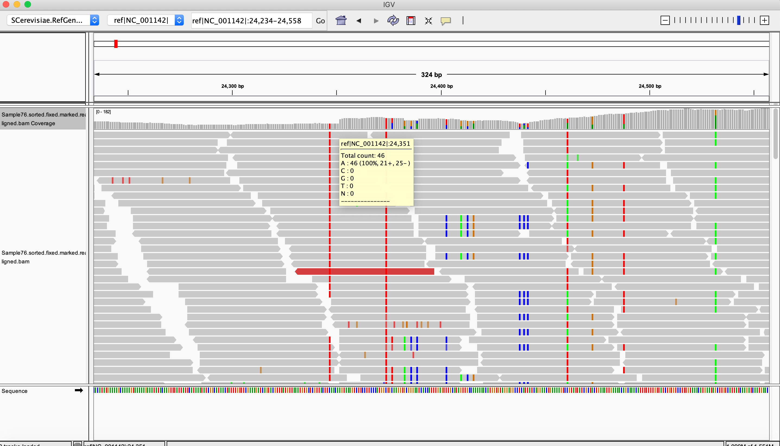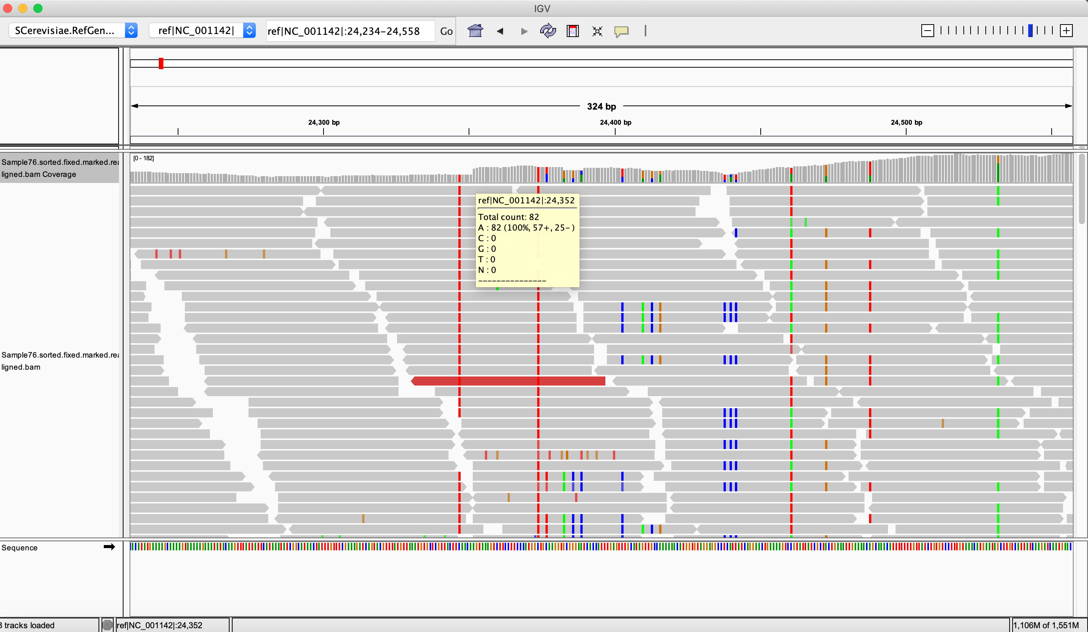

**Figure 2:** a. Integrated genome viewer (IGV) screenshot of the theorized initial breakpoint (24,351). Read count increases from 46 at 24,531 to 82 at 24,532 (b), and continues increasing out of the frame.

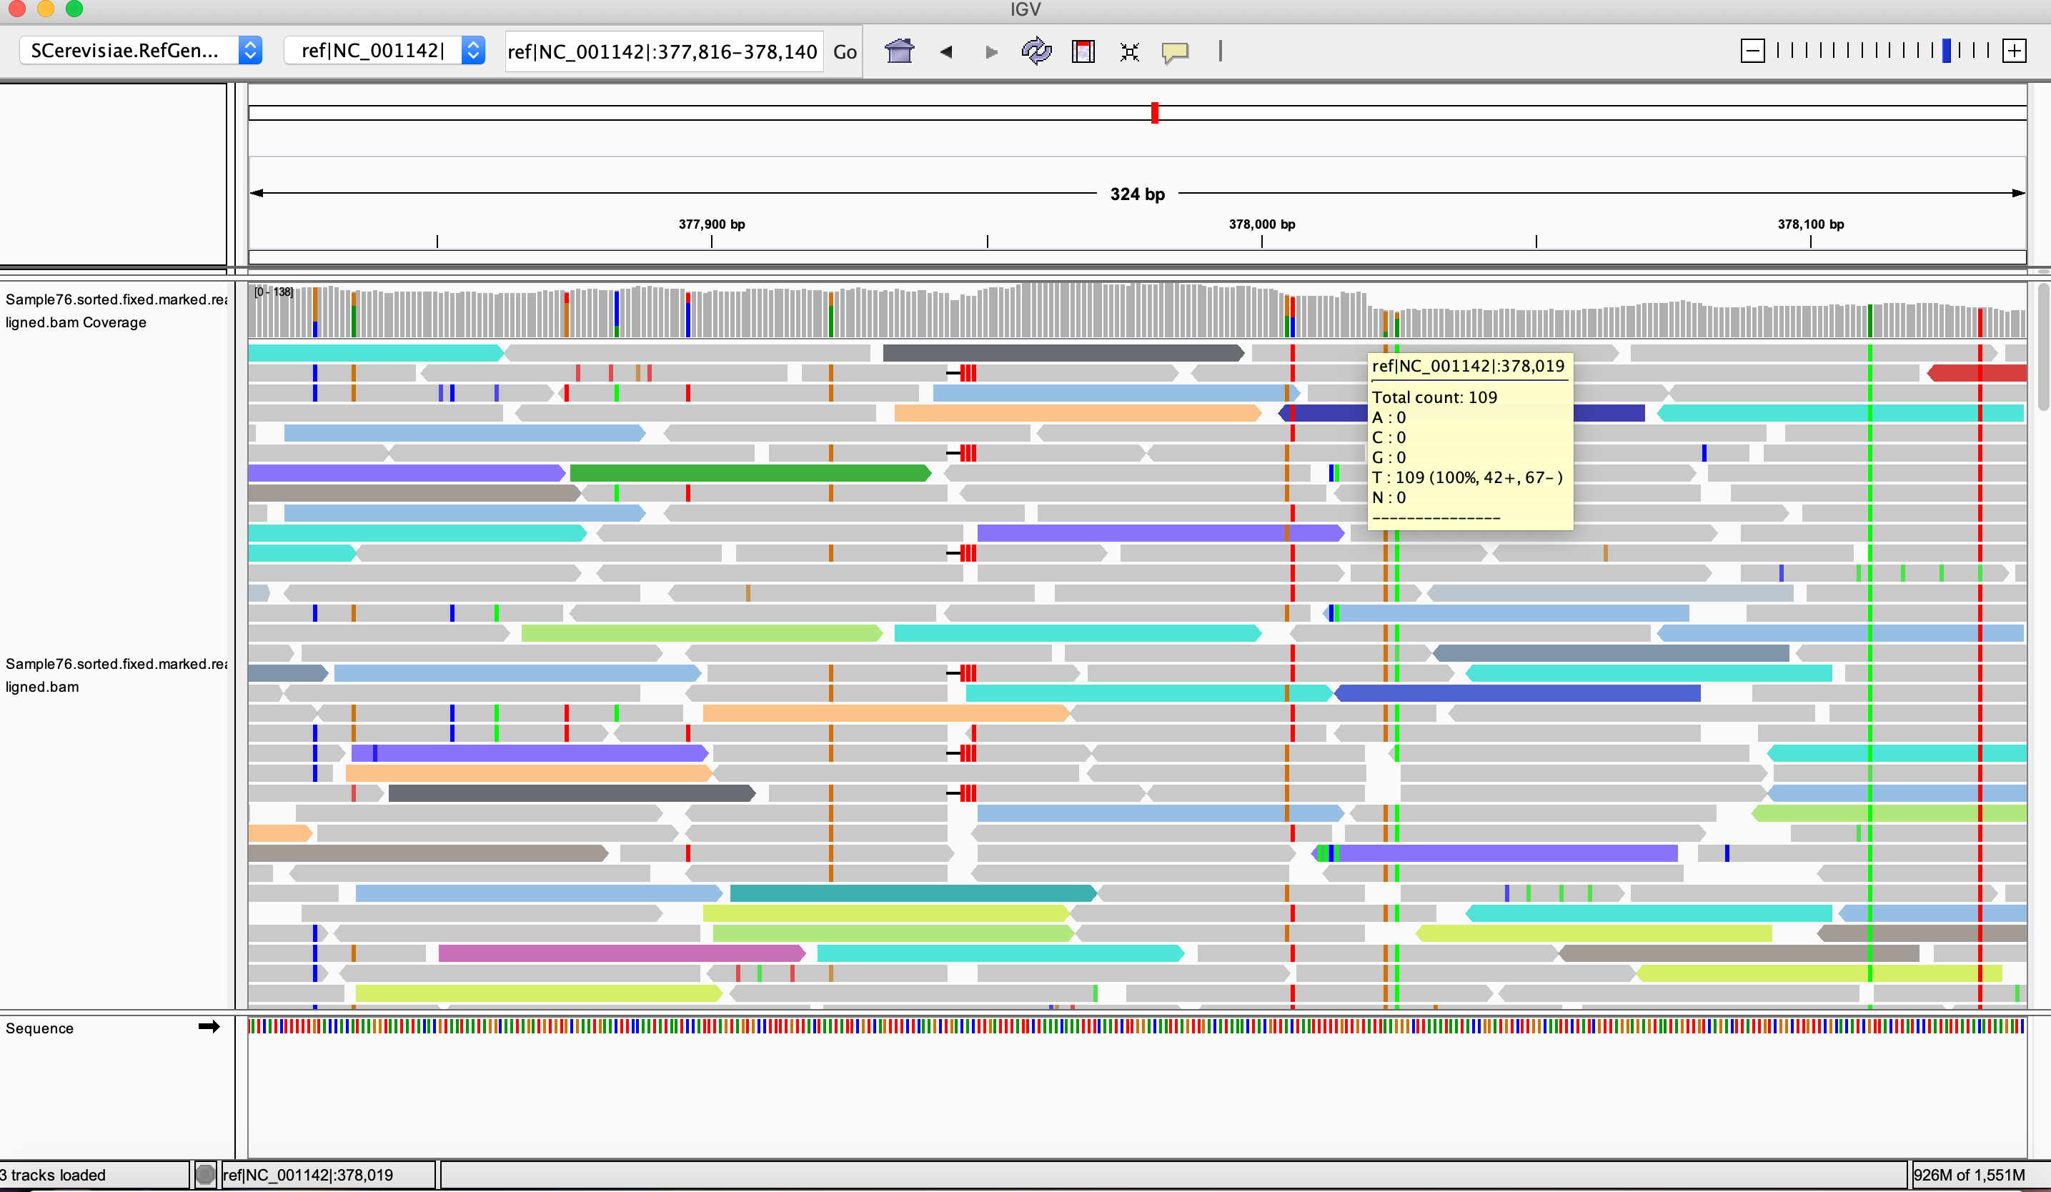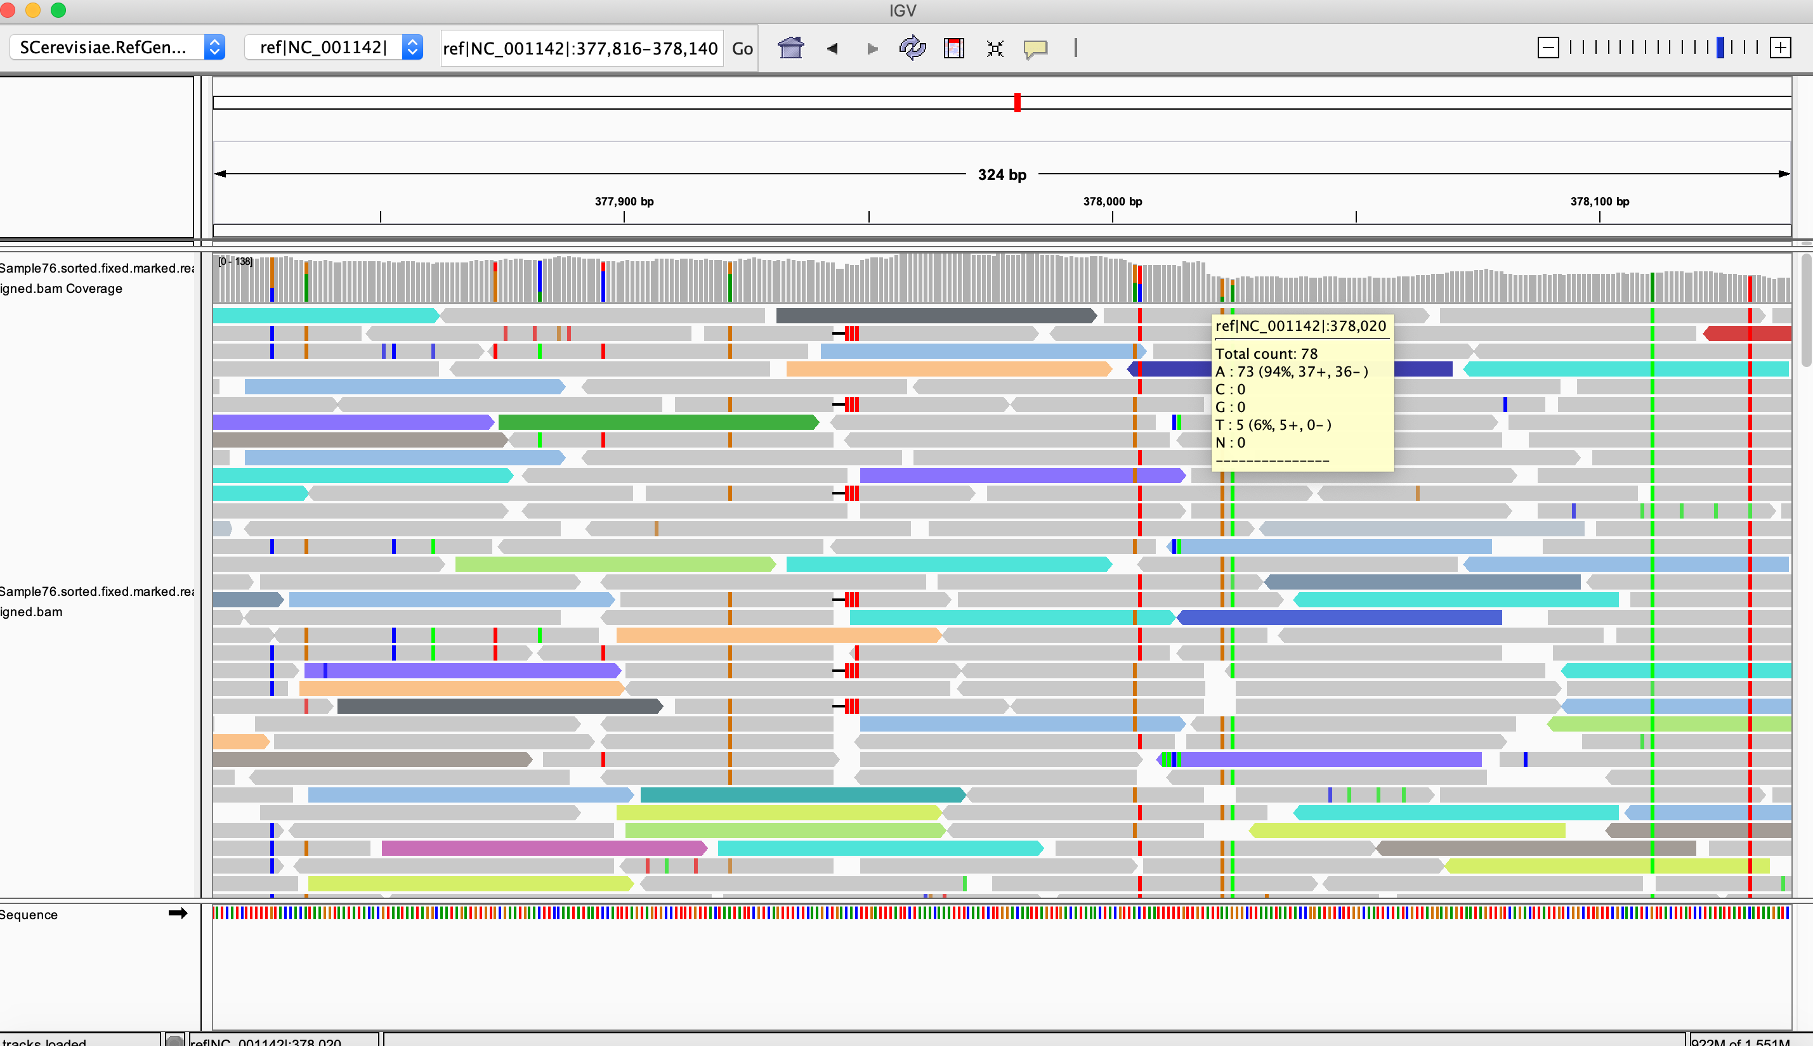

**Figure 3:** IGV screenshot of the theorized final breakpoint. Read count decreases from 109 at 378,019 (a) to 78 at 378,020 (b) (1.5-fold difference – consistent with 3 copies of each allele affected).

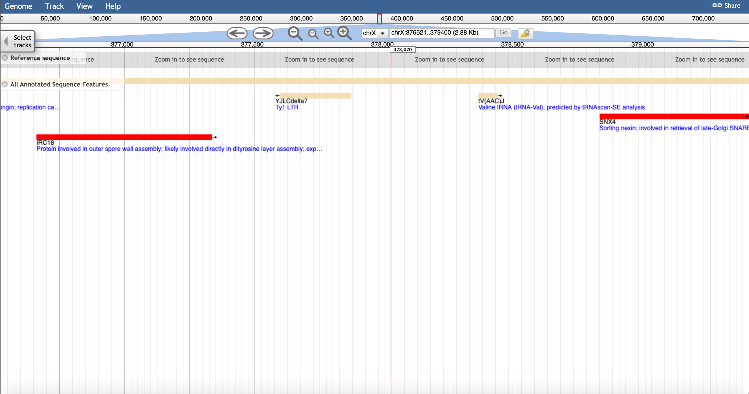

Screenshot of genome browser (SGD) indicating approximate breakpoint of segmental duplication of chromosome X – within 200 bp of the YJLCdelta7 Ty1 LTR.

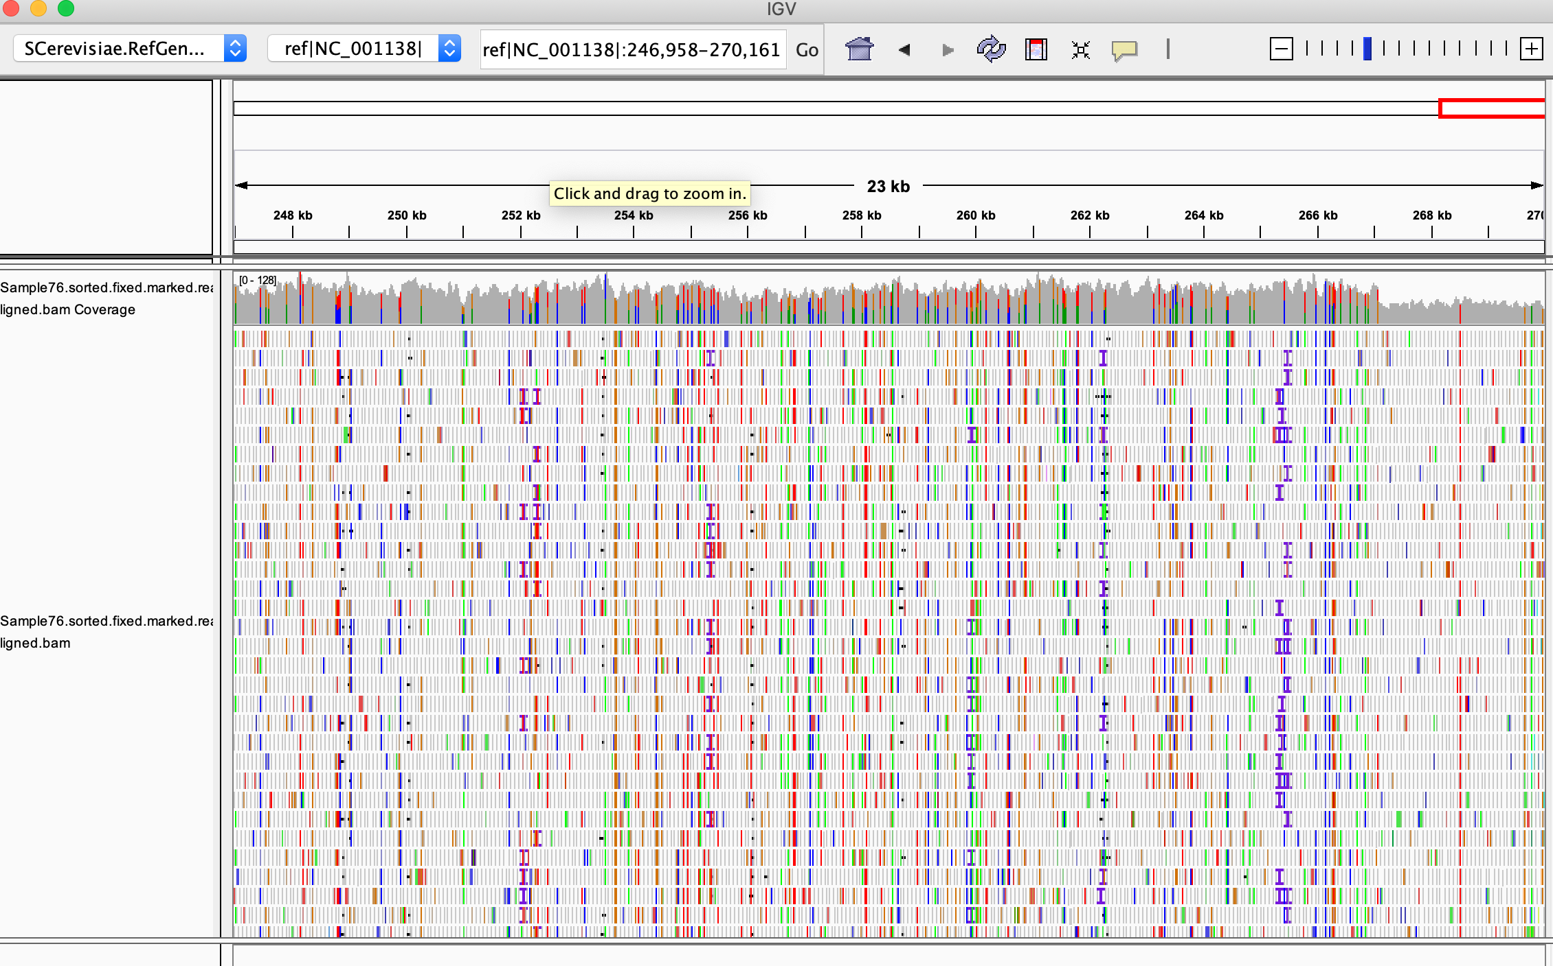

**Figure 4:** IGV screenshot of decrease in read count toward the end of chromosome VI: indicating a potential location of the duplicated arm of chromosome X in line 76.

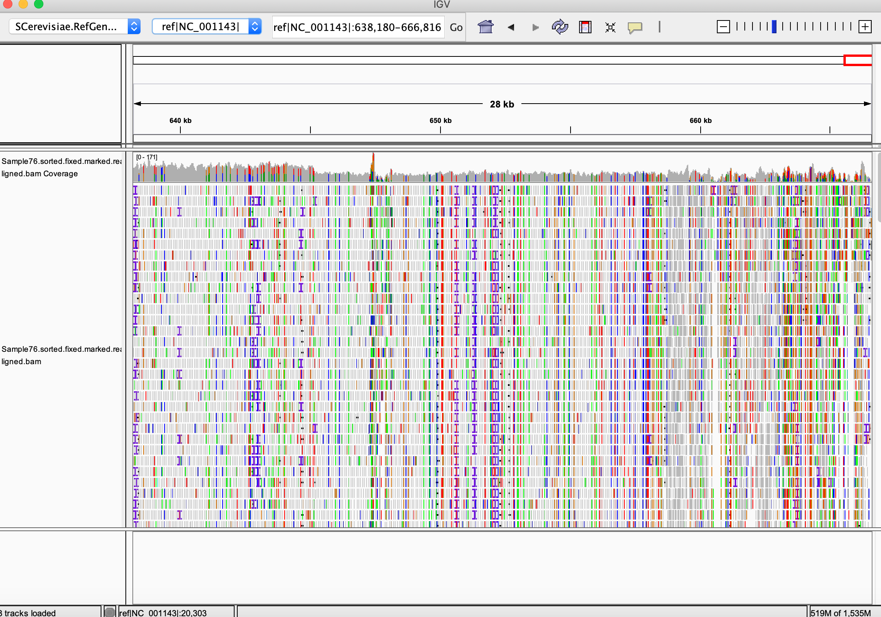

**Figure 5:** IGV screenshot of a decrease in copy number toward the end of chromosome XI, indicating a potential candidate for the location of the partially duplicated arm of chromosome X in line 76.



**Figure 6:** Heatmap depicting differential gene expression at the whole-chromosome level in aneuploid lines, when compared to ancestral expression levels.



**Figure 7:** Boxplots showing that gene expression levels (as measured by log2(FPKMratio)) are as expected for aneuploid chromosomes. Boxes in blue represent monosomic chromosomes in the line, boxes in red represent trisomic chromosomes in the line, dark red boxes indicate tetrasomic chromosomes, pink represents partially duplicated chromosomes, and gray boxes are euploid chromosomes. Red line indicates expected log2 ratio for a 1.5x increase in gene dosage, and the blue line represents expected log2 ratio for a 0.5x decrease in gene dosage. Gray middle line indicates no change in gene dosage.

|  |  |
| --- | --- |
| Trisomic Chromosome | Expected median/mode of ratio of gene expression when compared to euploid |
| I | 0.98130081 |
| II | 0.9371118 |
| III | 0.97417272 |
| IV | 0.8875 |
| V | 0.9541502 |
| VI | 0.97811994 |
| VII | 0.91717325 |
| VIII | 0.95566112 |
| IX | 0.96482814 |
| X | 0.94149766 |
| XI | 0.94740973 |
| XII | 0.91787072 |
| XIII | 0.92917629 |
| XIV | 0.93929961 |
| XV | 0.91717325 |
| XVI | 0.92703533 |

Table ^: Expected trans genes ratios for trisomic chromosomes.



Figure ^: Ratio distribution plots of euploid progenitor lines compared to the ancestor. This plot: lab strain.



Figure ^: Ratio distribution plots of euploid progenitor lines compared to the ancestor. This plot: hybrid strain.



Figure ^: a. Cis genes located on chromosome I for line 7 (hybrid strain), b. trans genes (located elsewhere in the genome) for line 7 (hybrid strain). C. cis genes chromosome I for line 18 (hybrid strain), d. trans genes for line 18, e. cis genes for chromosome I line 152 (lab strain), f. trans genes line 152, g. cis genes chromosome I line 11 (hybrid strain), h. trans genes line 11



Figure ^: a is line 4 cis genes chromosome V, b is line 4 trans genes chromosome V, c is line 49 cis, d is like 49 trans, e is line 117 cis, f is line 117 trans, g is line 123 cis, h is line 123 trans



Figure ^: a. line 59 chr VII cis genes, b. line 59 trans genes, c. line 61 cis genes, d. line 61 trans genes



Figure ^: a. line 108 chr VIII cis genes, b. line 108 trans genes, c. line 152 chr VIII cis genes, d. line 152 trans genes



Figure ^: a. line 15 chr IX cis genes (trisomic), b. line 15 trans genes, c. line 88 cis, d. line 88 trans, e. line 119 cis, f. line 119 trans, g. line 76 cis, h. line 76 trans, i. line 29 cis (monosomic), j. line 29 trans, k. line 108 cis (monosomic), l. line 108 trans

Figure ^: a. cis genes chromosome X line 76 (partially trisomic), b. trans genes line 76



Figure ^: a. cis genes chromosome XII line 18 (trisomic), b. trans genes line 18



Figure ^: a. cis genes chromosome XIV, line 9 (trisomic), b. trans genes line 9.



Figure ^: a. cis genes chromosome XV, line 11 (trisomic), b. trans genes line 11. 

Figure^: a. cis genes chromosome XVI line 112 (trisomic), b. trans genes line 112, c. cis genes line 8 (tetrasomic), d. trans genes line 8

**Figure 8:** Ratio distribution of cis and trans genes for two lines with trisomy VIII. Red dotted line: average ratio compared to ancestor, black line: ratio of 1 (no change in dose compared to ancestor), green line: ratio of 0.5 compared to ancestor (expected for monosomic genes), magenta line: ratio of 1.5 compared to ancestor (expected for trisomic genes).

** This is an example of plots that I will include – I have a lot more, I just need to modify them to look like this one.

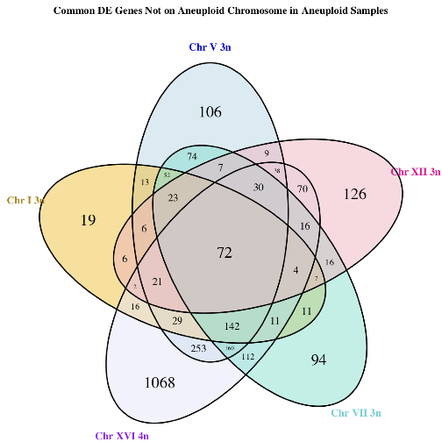

**Figure 9:** Aneuploids for different aneuploid chromosomes share differentially expressed genes located on euploid chromosomes

*** This is also an example of just one of the graphs I would add (and one way of displaying the information). I will make more of these with more data and include an alternative way of displaying the data.

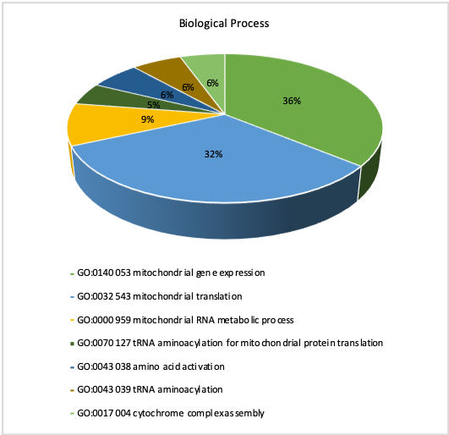

**Figure 10:** Hybrid euploid lines share a common gene expression signature, likely caused by mutation accumulation. GO analysis indicated that most of these genes are related to mitochondrial function.

** I still need to make one of these for lab strain samples.

**Figure 11:** Percentage of genes differentially expressed located on cis (aneuploid) chromosome and trans (non-aneuploid) chromosomes

**Figure 12:** Breakdown of genes on aneuploid chromosomes by compensation type. Shown is average percentage of genes on the given aneuploid chromosome. ** I will likely redo this later and make it look better.

**Figure 24:** Plot indicating the average number of differentially expressed environmental response (ESR) genes in the aneuploid lines, arranged by chromosome. Plot also indicates the number of shared ESR genes between samples that are aneuploid for the same chromosome (genetic background and ploidy not taken into account). Chromosomes with no bars were not sampled in our analyses.

**Figure 25:** Pie chart indicating the percentage of genes falling into various GO categories for ESR genes differentially expressed in hybrid euploid samples.

Anders, K. R., J. R. Kudrna, K. E. Keller, B. Kinghorn, E. M. Miller *et al.*, 2009 A strategy for constructing aneuploid yeast strains by transient nondisjunction of a target chromosome. BMC Genet 10**:** 36.

Anders, S., P. T. Pyl and W. Huber, 2015 HTSeq—a Python framework to work with high-throughput sequencing data. Bioinformatics 31**:** 166-169.

Anderson, M. Z., A. Saha, A. Haseeb and R. J. Bennett, 2017 A chromosome 4 trisomy contributes to increased fluconazole resistance in a clinical isolate of Candida albicans. Microbiology 163**:** 856-865.

Audrey P Gasch, J. H., Michael A Newton, Maria Sardi, Mun Yong, Zhishi Wang, 2016 Further support for aneuploidy tolerance in wild yeast and effects of dosage compensation on gene copy-number evolution. eLIFE 5**:** 1-12.

Birchler, J. A., J. Hiebert and K. Paigen, 1990 Analysis of autosomal dosage compensation involving the alcohol dehydrogenase locus in Drosophila melanogaster. Genetics 124**:** 677-686.

Birchler, J. A., and K. J. Newton, 1981 Modulation of protein levels in chromosomal dosage series of maize: the biochemical basis of aneuploid syndromes. Genetics 99**:** 247-266.

Bonney, M. E., H. Moriya and A. Amon, 2015 Aneuploid proliferation defects in yeast are not driven by copy number changes of a few dosage-sensitive genes. Genes & development 29**:** 898-903.

Campbell, D., J. S. Doctor, J. H. Feuersanger and M. M. Doolittle, 1981 Differential mitotic stability of yeast disomes derived from triploid meiosis. Genetics 98**:** 239-255.

Carlson M, M. B., 2015 TxDb.Scerevisiae.UCSC.sacCer3.sgdGene: Annotation package for TxDb object(s). R package version 3.2.2.

Chandler, C. H., 2017 When and why does sex chromosome dosage compensation evolve? Ann N Y Acad Sci 1389**:** 37-51.

Charlesworth, B., 1991 The evolution of sex chromosomes. Science 251**:** 1030-1033.

Chen, D., W. M. Toone, J. Mata, R. Lyne, G. Burns *et al.*, 2003 Global transcriptional responses of fission yeast to environmental stress. Mol Biol Cell 14**:** 214-229.

Chen, Z. X., and B. Oliver, 2015 X Chromosome and Autosome Dosage Responses in Drosophila melanogaster Heads. G3 (Bethesda) 5**:** 1057-1063.

Devlin, R. H., D. G. Holm and T. A. Grigliatti, 1982 Autosomal dosage compensation Drosophila melanogaster strains trisomic for the left arm of chromosome 2. Proc Natl Acad Sci U S A 79**:** 1200-1204.

Dumetz, F., H. Imamura, M. Sanders, V. Seblova, J. Myskova *et al.*, 2017 Modulation of aneuploidy in Leishmania donovani during adaptation to different in vitro and in vivo environments and its impact on gene expression. MBio 8**:** e00599-00517.

Eduardo M Torres, M. S., Angelika Amon, 2016 No current evidence for widespread dosage compensation in S. cerevisiae. eLIFE 5**:** 1-19.

Gasch, A. P., P. T. Spellman, C. M. Kao, O. Carmel-Harel, M. B. Eisen *et al.*, 2000 Genomic expression programs in the response of yeast cells to environmental changes. Molecular biology of the cell 11**:** 4241-4257.

Guo, M., D. Davis and J. A. Birchler, 1996 Dosage effects on gene expression in a maize ploidy series. Genetics 142**:** 1349-1355.

Hangnoh Lee, D.-Y. C., Cale Whitworth, Robert Eisman, Melissa Phelps, John Roote, Thomas Kaufman, Kevin Cook, Steven Russell, Teresa Przytycka, Brian Oliver, 2016 Effects of Gene Dose, Chromatin, and Network Topology on Expression in Drosophila melanogaster. PLoS Genetics 12.

Hassold, T., and P. Hunt, 2001 To err (meiotically) is human: the genesis of human aneuploidy. Nature Reviews Genetics 2**:** 280.

James Hose, C. M. Y., Maria Sardi, Zhishi Wang, Michael A Newton, Audrey P Gasch, 2015 Dosage compensation can buffer copy-number variation in yeast. eLIFE 4**:** 1-27.

Kaya, A., M. V. Gerashchenko, I. Seim, J. Labarre, M. B. Toledano *et al.*, 2015 Adaptive aneuploidy protects against thiol peroxidase deficiency by increasing respiration via key mitochondrial proteins. Proc Natl Acad Sci U S A 112**:** 10685-10690.

Koo, D.-H., M. Jugulam, K. Putta, I. B. Cuvaca, D. E. Peterson *et al.*, 2018 Gene duplication and aneuploidy trigger rapid evolution of herbicide resistance in common waterhemp. Plant physiology 176**:** 1932-1938.

Kumaran, R., S.-Y. Yang and J.-Y. Leu, 2013 Characterization of chromosome stability in diploid, polyploid and hybrid yeast cells. PLoS One 8**:** e68094.

Lee, H., D.-Y. Cho, C. Whitworth, R. Eisman, M. Phelps *et al.*, 2016 Effects of gene dose, chromatin, and network topology on expression in Drosophila melanogaster. PLoS genetics 12**:** e1006295.

Li, H., B. Handsaker, A. Wysoker, T. Fennell, J. Ruan *et al.*, 2009 The sequence alignment/map format and SAMtools. Bioinformatics 25**:** 2078-2079.

Linder, R. A., J. P. Greco, F. Seidl, T. Matsui and I. M. Ehrenreich, 2017 The Stress-Inducible Peroxidase TSA2 Underlies a Conditionally Beneficial Chromosomal Duplication in Saccharomyces cerevisiae. G3 (Bethesda) 7**:** 3177-3184.

Lundberg, L. E., M. L. Figueiredo, P. Stenberg and J. Larsson, 2012 Buffering and proteolysis are induced by segmental monosomy in Drosophila melanogaster. Nucleic Acids Res 40**:** 5926-5937.

Makanae, K., R. Kintaka, T. Makino, H. Kitano and H. Moriya, 2013 Identification of dosage-sensitive genes in Saccharomyces cerevisiae using the genetic tug-of-war method. Genome research 23**:** 300-311.

Malone, J. H., D. Y. Cho, N. R. Mattiuzzo, C. G. Artieri, L. Jiang *et al.*, 2012 Mediation of Drosophila autosomal dosage effects and compensation by network interactions. Genome Biol 13**:** r28.

Marin, I., M. L. Siegal and B. S. Baker, 2000 The evolution of dosage-compensation mechanisms. system 18**:** 19.

Marinoni, G., M. Manuel, R. F. Petersen, J. Hvidtfeldt, P. Sulo *et al.*, 1999 Horizontal transfer of genetic material amongSaccharomyces yeasts. Journal of Bacteriology 181**:** 6488-6496.

Matos, I., M. Machado, M. Schartl and M. Coelho, 2015 Gene expression dosage regulation in an allopolyploid fish. PloS one 10**:** e0116309.

McAnally, A. A., and L. Y. Yampolsky, 2009 Widespread transcriptional autosomal dosage compensation in Drosophila correlates with gene expression level. Genome Biol Evol 2**:** 44-52.

Medici, M., E. Porcu, G. Pistis, A. Teumer, S. J. Brown *et al.*, 2014 Identification of novel genetic Loci associated with thyroid peroxidase antibodies and clinical thyroid disease. PLoS Genet 10**:** e1004123.

Mulla, W., J. Zhu and R. Li, 2014 Yeast: a simple model system to study complex phenomena of aneuploidy. FEMS microbiology reviews 38**:** 201-212.

Osley, M. A., and L. M. Hereford, 1981 Yeast histone genes show dosage compensation. Cell 24**:** 377-384.

Peter R. Eriksson, D. G., V. Nagarajavel, and David J. Clark, 2012 Regulation of Histone Gene Expression in Budding Yeast. Genetics 191**:** 7-20.

Robinson, M. D., D. J. McCarthy and G. K. Smyth, 2010 edgeR: a Bioconductor package for differential expression analysis of digital gene expression data. Bioinformatics 26**:** 139-140.

Strope, P. K., D. A. Skelly, S. G. Kozmin, G. Mahadevan, E. A. Stone *et al.*, 2015 The 100-genomes strains, an S. cerevisiae resource that illuminates its natural phenotypic and genotypic variation and emergence as an opportunistic pathogen. Genome research 25**:** 762-774.

Team, R. C., 2013 R: A language and environment for statistical computing.

Thomas, P. D., M. J. Campbell, A. Kejariwal, H. Mi, B. Karlak *et al.*, 2003 PANTHER: a library of protein families and subfamilies indexed by function. Genome research 13**:** 2129-2141.

Todd, R. T., A. Forche and A. Selmecki, 2017 Ploidy Variation in Fungi–Polyploidy, Aneuploidy, and Genome Evolution. Microbiology spectrum 5.

Torres, E. M., N. Dephoure, A. Panneerselvam, C. M. Tucker, C. A. Whittaker *et al.*, 2010 Identification of aneuploidy-tolerating mutations. Cell 143**:** 71-83.

Torres, E. M., T. Sokolsky, C. M. Tucker, L. Y. Chan, M. Boselli *et al.*, 2007 Effects of aneuploidy on cellular physiology and cell division in haploid yeast. Science 317**:** 916-924.

Trapnell, C., A. Roberts, L. Goff, G. Pertea, D. Kim *et al.*, 2012 Differential gene and transcript expression analysis of RNA-seq experiments with TopHat and Cufflinks. Nature protocols 7**:** 562-578.

Veitia, R. A., S. Bottani and J. A. Birchler, 2008 Cellular reactions to gene dosage imbalance: genomic, transcriptomic and proteomic effects. Trends in Genetics 24**:** 390-397.

Wakabayashi, H., C. Tucker, G. Bethlendy, A. Kravets, S. L. Welle *et al.*, 2017 NuA4 histone acetyltransferase activity is required for H4 acetylation on a dosage-compensated monosomic chromosome that confers resistance to fungal toxins. Epigenetics Chromatin 10**:** 49.

Wickham, H., 2016 *ggplot2: elegant graphics for data analysis*. Springer.

Yona, A. H., Y. S. Manor, R. H. Herbst, G. H. Romano, A. Mitchell *et al.*, 2012 Chromosomal duplication is a transient evolutionary solution to stress. Proceedings of the National Academy of Sciences 109**:** 21010-21015.

Zhang, R., L. Hao, L. Wang, M. Chen, W. Li *et al.*, 2013 Gene expression analysis of induced pluripotent stem cells from aneuploid chromosomal syndromes. BMC genomics 14**:** S8.

Zhu, Y. O., M. L. Siegal, D. W. Hall and D. A. Petrov, 2014 Precise estimates of mutation rate and spectrum in yeast. Proceedings of the National Academy of Sciences 111**:** E2310-E2318.

Zillikens, M. C., S. Demissie, Y. H. Hsu, L. M. Yerges-Armstrong, W. C. Chou *et al.*, 2017 Erratum: Large meta-analysis of genome-wide association studies identifies five loci for lean body mass. Nat Commun 8**:** 1414.